|  |  |  |  |  |
| --- | --- | --- | --- | --- |
| Tool Maintenance | | | | |
|  |  | | |  |
| Jovany Romo Spring 2021 | | | | |
|  | | Project Proposal Plan |  | |

TABLE OF CONTENTS

[1. Executive Summary 5](#_Toc69744746)

[2. System Request 6](#_Toc69744747)

[3. Work Plan 8](#_Toc69744748)

[4. Feasibility Analysis 9](#_Toc69744749)

[5. Requirements Definition 11](#_Toc69744750)

[6. Analysis of the Current Systems 12](#_Toc69744751)

[7. Use Case #1 13](#_Toc69744752)

[Use Case #2 15](#_Toc69744753)

[Use Case #3 17](#_Toc69744754)

[Use Case #4 18](#_Toc69744755)

[Use Case #5 20](#_Toc69744756)

[8. Process Model 22](#_Toc69744757)

[9. Data Model 26](#_Toc69744758)

[10. Interface Design 27](#_Toc69744759)

[11. Program Design Specifications 29](#_Toc69744760)

[12. Physical Data Model 30](#_Toc69744761)

[Appendix 32](#_Toc69744762)

# Executive Summary

This tool maintenance application will be able to give associates a way of being able to maintain current tools while also improving the current system in place.

Tool Maintenance will work by keeping track of all the tools in inventory and when they have been rented out to customers. Associates will be able to use the application by visiting the designated website.

This approach will help our fellow associates efficiently do their jobs. The focus of the project will be for the repair associates be able to keep track of maintenance needed on tools. Additionally, it would also provide a more robust and through system compared to the current system.

To summarize, Tool Maintenance will provide a proper way of maintaining the tools that we rent out at The Home Depot, which increase profits and reduce the downtime of tools.

# System Request

|  |  |
| --- | --- |
| System Request – Tool Rental Management | |
| Project Sponsor: | Jovany Romo, Project Lead, Project Analysist  Tony Cespedes, Department Head of Tool Rentals |
| Business Need: | This project is being proposed to maximize productivity in the tool rental department.   * Employees in the tool rental department must manually keep track of tools available to be rented, and which tools would need to be maintained and what maintenance would be needed. * The longer that tools are in the maintenance status, the longer customers will have to wait to rent out our tools. |
| Business Requirements: | Using a web-based system in tool rental departments across our locations will improve the productivity of those departments. The application should include the following:   * Track the elapsed time of a returned tool. * Includes a description of the tool and the issues related to it. * Suggest what needs to be maintained once the product has been rented out for a specified amount of time. (I.e., oil, oil filter, etc.) * List tools that are available to be rented out. |
| Business Value: | The expectations of this web-based application are to improve the management of tools and time in this department and increase the quantity available for customers to rent out, supplying an easier way for associates to carry out their tasks.    Expectations of the value for the company:   * Increased productivity of associates. * Increased quantity of tools available to be rented, which would in-turn increase overall profit from this department. * More streamlined process for associates’ tasks.     Future Expectations that are expected once this feature is implemented:   * Create reports of productivity of associates. * The approximate cost of how much is needed for a tool to be repaired and maintained. This could suggest adjustments to the price of renting the tool for it to still be profitable. * Show which tools are in the highest demand and suggest how many should be kept in stock. |
| Special Issues or Constraints: | * We are unfamiliar with the process of developing a fully functioning web-based application that could meet the requirements needed for this project to function. * A significant amount of time for researching would be needed to do this task, along with shadowing associates in the tool rental department. * The company would need to invest time training tool rental associates on how to use this new system. |

# Work Plan

Once I am further along with this project, I will then be able to make a work plan.

# Feasibility Analysis

|  |  |  |
| --- | --- | --- |
| Feasibility Analysis Assessment Factors | | |
| Technical Feasibility: Can we build this? | | |
| Consider: | **Familiarity with application:** The less familiarity there is, the more risk there is. | **Familiarity with technology:** The less familiarity there is, the more risk there is. |
| **Project size:** The larger the project, the more risks. | **Compatibility:** The harder it is to integrate the system with the company’s existing technology, the higher the risk will be. |
| * The size of the project initially will be intimidating but straight forward with proper planning and research. * Can be scaled out to include more features in the future. * We have a lot of prior experience with C# and HTML. * .NET Core is useable across most operating systems and web browsers. | | |
| Economic Feasibility: Should We Build It? | | |
| Factors: | Development Costs | Annual Operating Costs |
| Annual benefits (cost savings and/or increased revenues) | Intangible benefits and costs |
| * The initial cost will be a significant amount of time investment will be required for research. * Will need to pay for a domain to have a useable website. * More money will be saved as a result of being able to track what tools require maintenance. | | |
| Organizational Feasibility: If we build it, will they come? | | |
| Consider: | • Is the project strategically aligned with the business? | • Project champion(s)? |
| • Senior management? | • Users and other stakeholders? |
| * I am the project champion. * I will be able to experience creating an MVC project from scratch. * Any Home Depot employee will be able to easily understand this system. | | |

# Requirements Definition

**Functional Requirements**

* Needs to be able to connect to a database.
* Have a clear and easy to understand interface.
* Display navigation tabs on its pages.
  + Inventory
  + Rentals
  + Repairs
* Provide managers and department heads to be able to input new information or edit existing information in the database.

**Nonfunctional Requirements**

* **Operational**
  + The system should be able to run on any web browser.
* **Performance**
  + The system should only be available for associates.
  + The system should not take longer than 30 seconds to load.
* **Security**
  + The system’s code and database should only be accessible to the development team.
  + The system should only be accessible after entering a login screen.
* **Cultural and Political**
  + This system should be formal and not cause any cultural harm.

# Analysis of the Current Systems

The analysis of the current system is that currently technical and rental associates must manually keep track of tools to rent out and what must be repaired.

Model of the Current System

* + The rental associates are currently able to create rental orders and make rental tickets.

Model of the Future System

* + With this future system implemented, associates will also be able to keep track of the recommended maintenance needed for each tool after a certain amount of use has passed.
  + This new system will also replace the current system with a more intuitive UI.

# Use Case #1

|  |  |  |
| --- | --- | --- |
| Use Case Name: Technician Associates Keeping Track of Repair Tickets | ID: 1 | Priority: 1 |
| Actor: | Technician Associates | |
| Description: | Technician Associates need to be able to manage repair tickets for tools. The system will be able to satisfy this request by tracking how long tools have been rented out for and how long it has been since the last time they have been repaired. | |
| Trigger: A Technician Associate needs to check repair tickets. | **Type**:  [X] External [ ] Temporal | |
| Preconditions: | 1. The Technician Associate is authenticated and authorized. 2. The database for the tools is kept up-to-date and on-line. | |
| Normal Course: | 1. The Technician Associate logins into the website to use the web application and clicks on “Repair Tickets”. 2. The system lists all the current tickets the need to be done.    1. Each listed repair ticket will show the elapsed time, indicating how long it has needed maintenance and/or repair. 3. The system specifies a checklist for the Technician Associate to go through and make sure all the appropriate maintenance has been completed. 4. Allows for the Technician Associate to add notes to the ticket. 5. The Technician marks the ticket as complete. | |
| Post conditions: | 1. The repair ticket is stored on the database, marked as closed. 2. The system marks the tool as available on hand inventory. 3. The system displays “The ticket is now closed.” 4. The Technician associate is then brought back to the repair tickets page, for the Associate to choose another repair ticket to work on, or they exit the web application. 5. The Technician Associate leaves the website. 6. The system is now closed. | |
| Exceptions: | Exceptions would not be applicable to this use case. | |

# Use Case #2

|  |  |  |
| --- | --- | --- |
| Use Case Name: Manager Updates Inventory | ID: 2 | Priority: 2 |
| Actor: | Manager | |
| Description: | The manager on duty needs to be able to update the inventory as needed. | |
| Trigger: | Type:  [X] External [ ] Temporal | |
| Preconditions: | 1. The Manager is authenticated and authorized. 2. The system is online. | |
| Normal Course: | 1. The manager logins into the system. 2. The manager clicks on the inventory page and will have access to administrative controls.    1. Add an item along with item information.    2. Editing an existing item.    3. Removing an existing item. 3. The system then updates the new information onto the database. | |
| Post conditions: | 1. The information is stored in the Inventory Management System. 2. The system displays “The inventory has now been updated.” 3. The system requests the manager to either repeat a task or to return to the inventory page. 4. The Manager exits the system. 5. The system is now closed. | |
| Exceptions: | E1: User cancels updating the inventory. (Occurs at step 2)   1. The user clicks on the cancel button. 2. System displays message “Are you sure you want to cancel?” 3. User clicks on “Yes.” 4. The system returns to the inventory page. | |

# Use Case #3

|  |  |  |
| --- | --- | --- |
| Use Case Name: Rental Associates Checking Available On Hand | ID: 3 | Priority: 3 |
| Actor: | Rental Associates | |
| Description: | Rental Associates needs to be able to quickly check which tools are available for a customer to rent out. | |
| Trigger: | Type:  [X] External [ ] Temporal | |
| Preconditions: | 1. The Rental Associate is authenticated and authorized. 2. The Inventory database is up-to-date and on-line. | |
| Normal Course: | 1. The Rental Associate logins into the system. 2. The Rental Associate clicks on the inventory page.    1. Search for inventory by name.    2. Filter the list by category. 3. The system displays information about a selected item. | |
| Post conditions: | 1. The Rental Associate will be able to let a customer know what tools are available for rent. 2. The Rental Associate will be able to either search for another tool or exit the web application. 3. The Rental Associate exits the website. 4. The system is closed. | |
| Exceptions: | Exceptions would not be applicable to this use case. | |

# Use Case #4

|  |  |  |
| --- | --- | --- |
| Use Case Name: Rental Associates Creating/Updating Customer Accounts | ID: 4 | Priority: 4 |
| Actor: | Rental Associates | |
| Description: | Rental Associates need to be able to add and update customer information. | |
| Trigger: | Type:  [X] External [ ] Temporal | |
| Preconditions: | 1. The Rental Associate is authenticated and authorized. 2. The Inventory database is up-to-date and on-line. 3. The customer database is up-to-date and on-line. | |
| Normal Course: | 1. The Rental Associate logins into the system. 2. The Rental Associate clicks on the Customers page.    1. Associates will be able to search for customers and be able to update the customer’s information.    2. Associate will be able to create a new customer account. 3. The Rental Associate then clicks “Save”. | |
| Post conditions: | 1. The customers’ database is now updated. 2. The system displays “Customer Added”/” Customer Information Updated.” 3. The Rental Associate exits the website. 4. The system is closed. | |
| Exceptions: | E1: The Rental Associate cancels updating the information/adding a new customer (Occurs at step 2)   1. The system displays “Are you sure you want to cancel?” 2. The user clicks “Yes” 3. The information is not saved. 4. The user exits the website. 5. The system is closed. | |

# Use Case #5

|  |  |  |
| --- | --- | --- |
| Use Case Name: Rental Associate Creating a Rental Ticket | ID: 5 | Priority: 5 |
| Actor: | Rental Associate | |
| Description: | The Rental Associate needs to be able to create tickets to be able to quote or rent out tools. | |
| Trigger: | Type:  [X] External [ ] Temporal | |
| Preconditions: | 1. The Rental Associate is authenticated and authorized. 2. The Inventory system is up-to-date and on-line. 3. The customer database is up-to-date and on-line. | |
| Normal Course: | 1. The Rental Associate specifies the tool(s) to be rented out by a customer. 2. Rental Associate will be able to show the cost of renting out the tool(s) for a specified amount of time. 3. The Rental Associate will be then go through the process of renting out the tools for the customer. | |
| Alternative Course: | 1. The Rental Associate will be able to produce a quote for the customer and print it for them. (Branch from step 2) | |
| Post conditions: | 1. The Inventory system updates the available quantity. 2. A Rental Ticket is created and stored with the customer and item information. | |
| Exceptions: | E1: The customer declines renting the tool(s). (Occurs at step 2)   1. The rental associate clicks on the cancel button. 2. The system displays message “Are you sure you want to cancel?” 3. User clicks on “Yes.” 4. The rental ticket is not created. 5. The user is brought back to an empty rental ticket. | |

# Process Model

Use Case #1 – Repair Tickets:

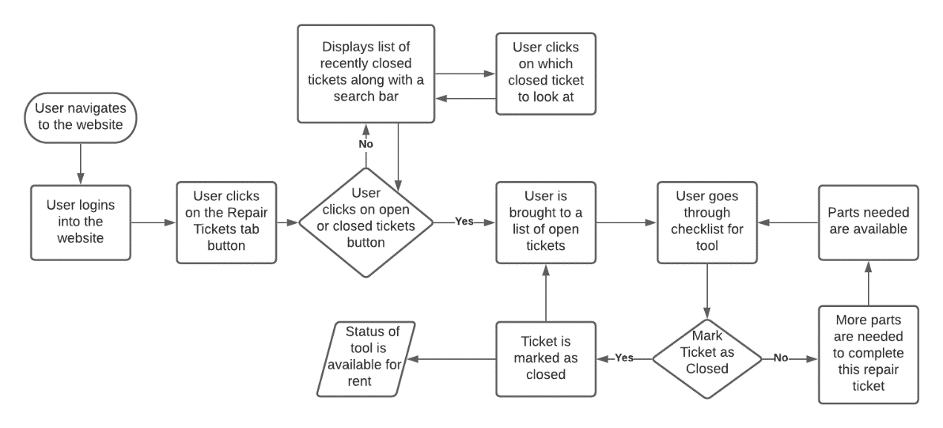

Use Case #2 – Inventory Management:

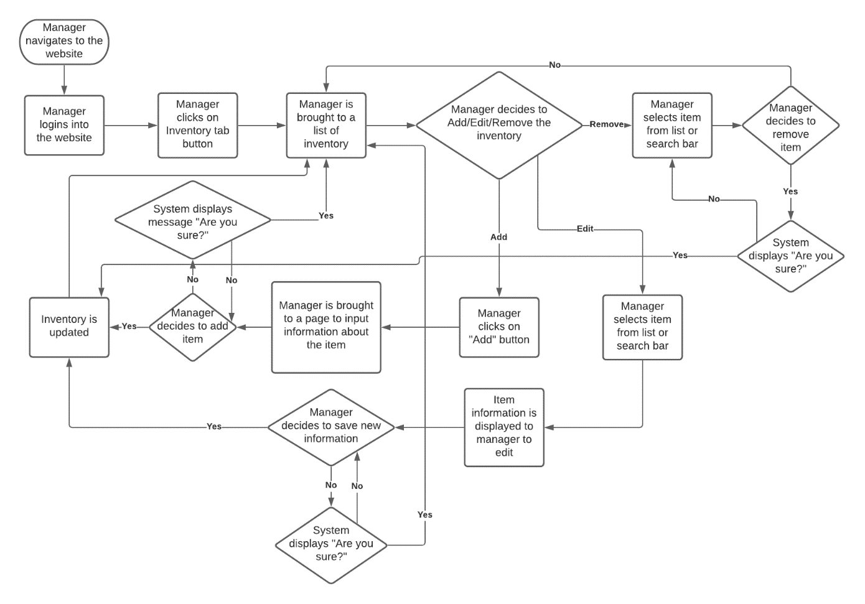

Use Case #3 – Available Inventory

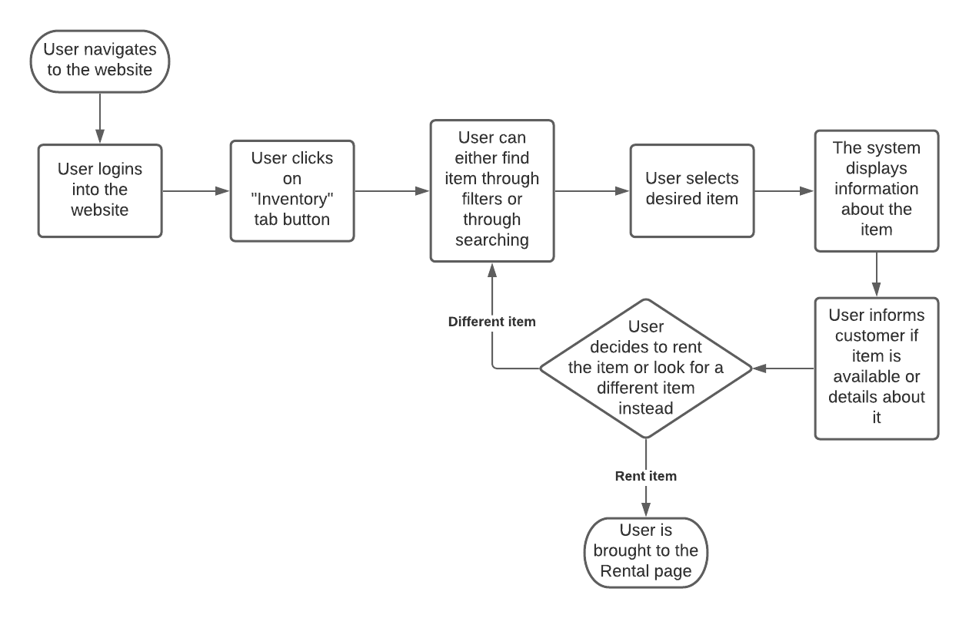

Use Case #4 – Customer Accounts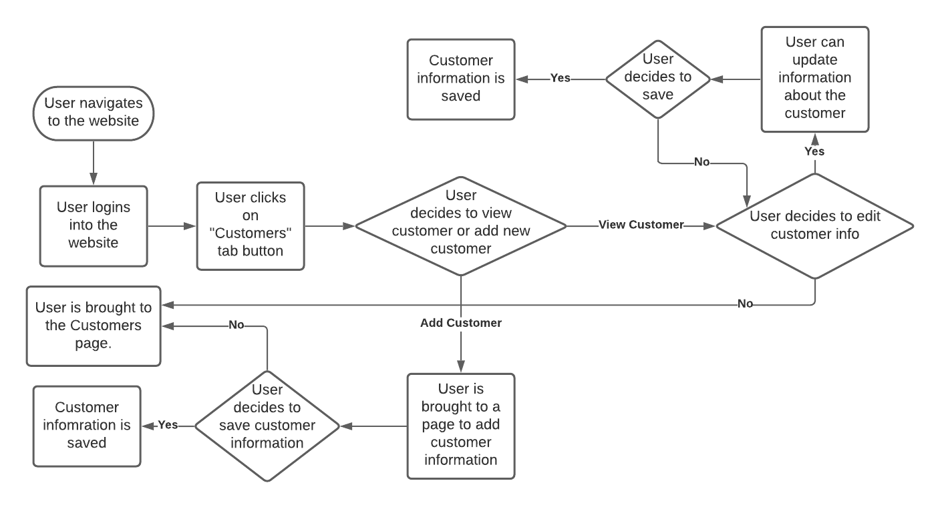

Use Case #5 – Rental Tickets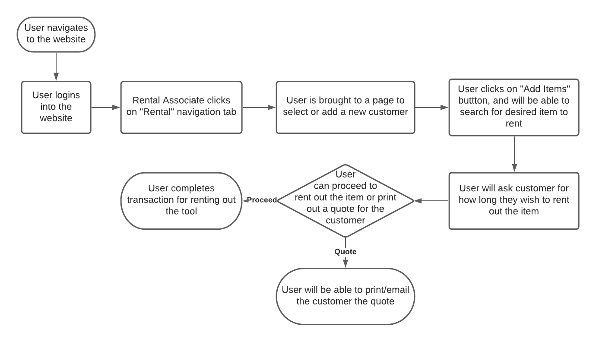

# Data Model

Initial Data Model

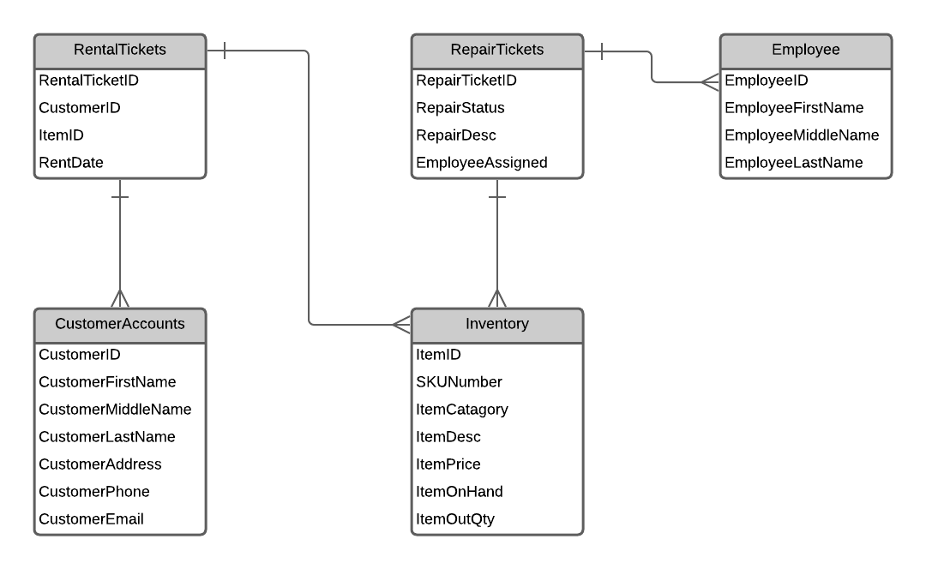

Updated:  
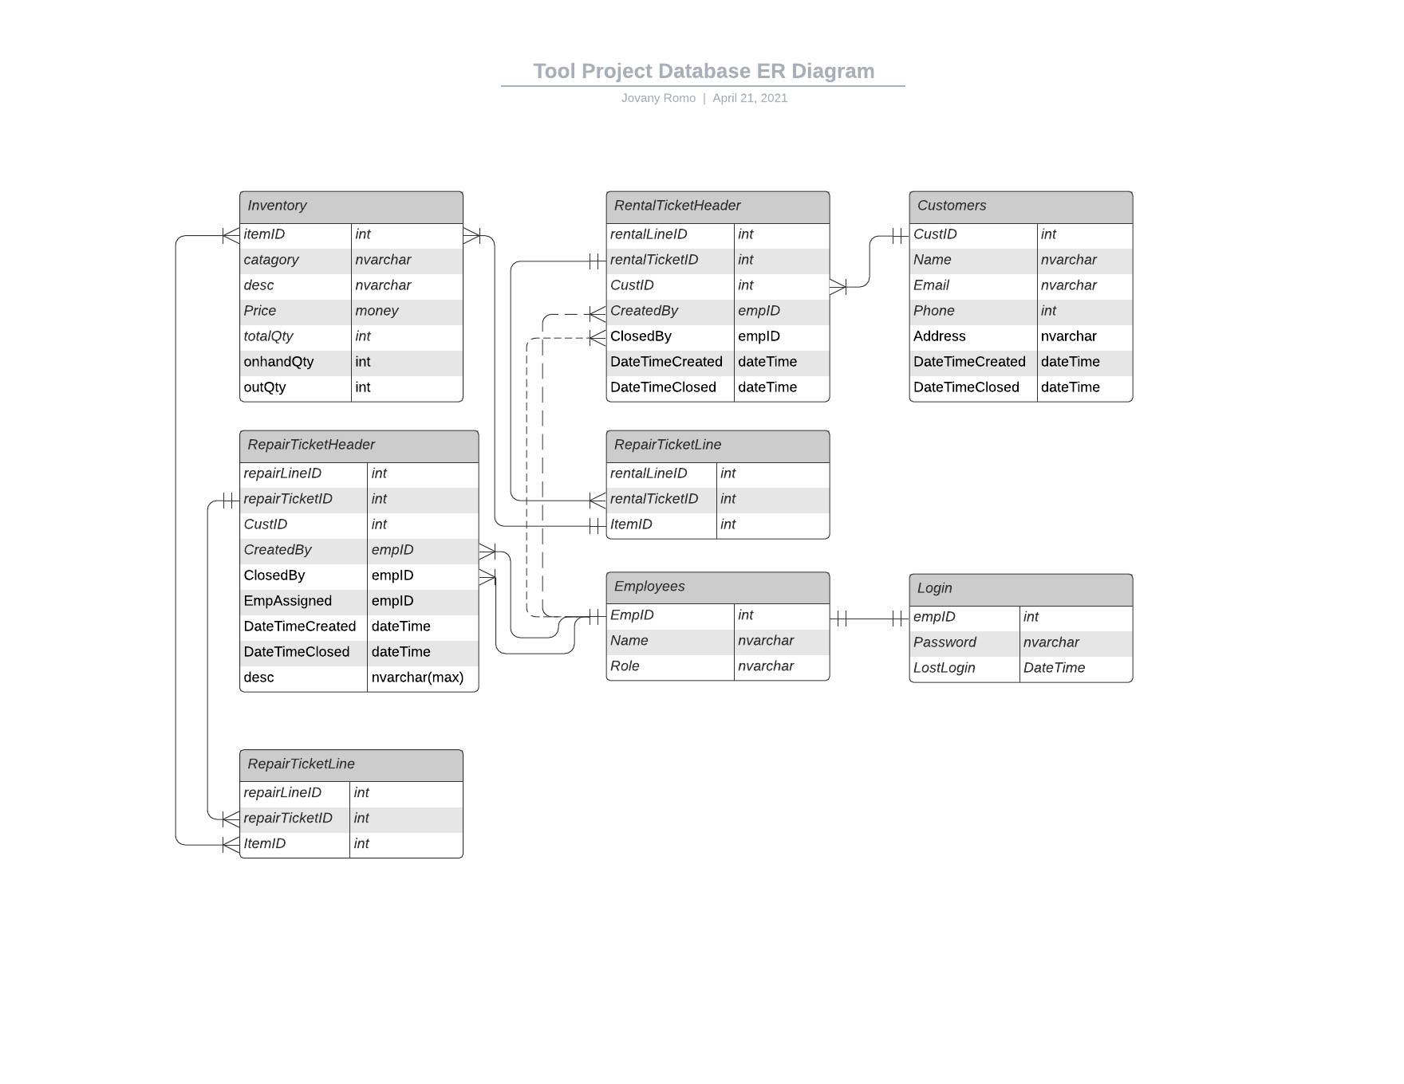

# Interface DesignC:\Users\jromo021627\Downloads\OneDrive_1_4-19-2021\RepairTicketsScreen.PNGC:\Users\jromo021627\Downloads\OneDrive_1_4-19-2021\ItemScreen.PNGC:\Users\jromo021627\Downloads\OneDrive_1_4-19-2021\InventoryScreen.PNGC:\Users\jromo021627\Downloads\OneDrive_1_4-19-2021\AddItemScreen.PNG

# Program Design Specifications

**Name:** Tool Maintenance

**Purpose:** To keep track of tools in inventory, to create rental tickets, along with maintaining and repairing tools in the store.

**Programmer:** Team Tool Maintenance

**Due Date:** The end of Summer 2021

|  |  |
| --- | --- |
| **Event** | **Output** |
| Navigate to website. | User is brought to a login screen in order to reach the main webpage. |
| User logins with appropriate credentials. | User is brought to the main webpage, where they can choose to view or change inventory, create rental tickets, or to create and manage repair tickets. |

Website must be ADA compliant.

Website must be compatible with desktop web browsers.

# Physical Data Model

Inventory System Model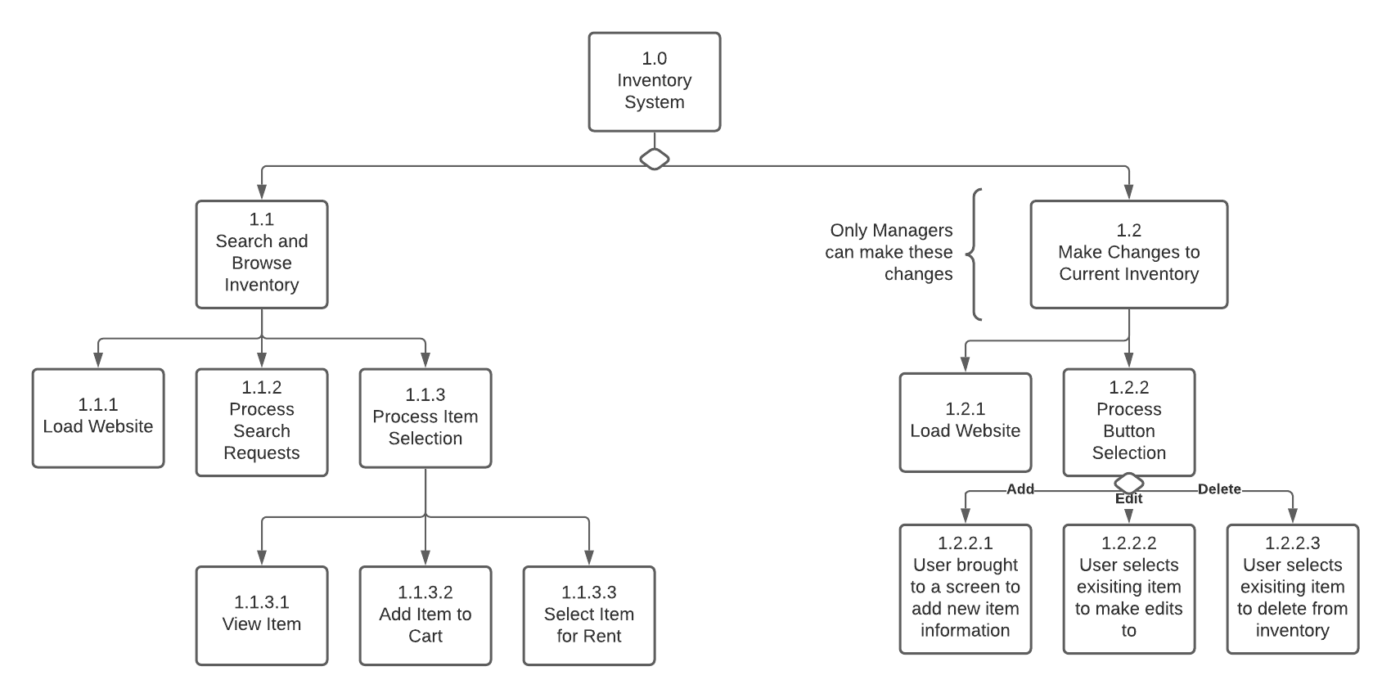

Rental System Model  
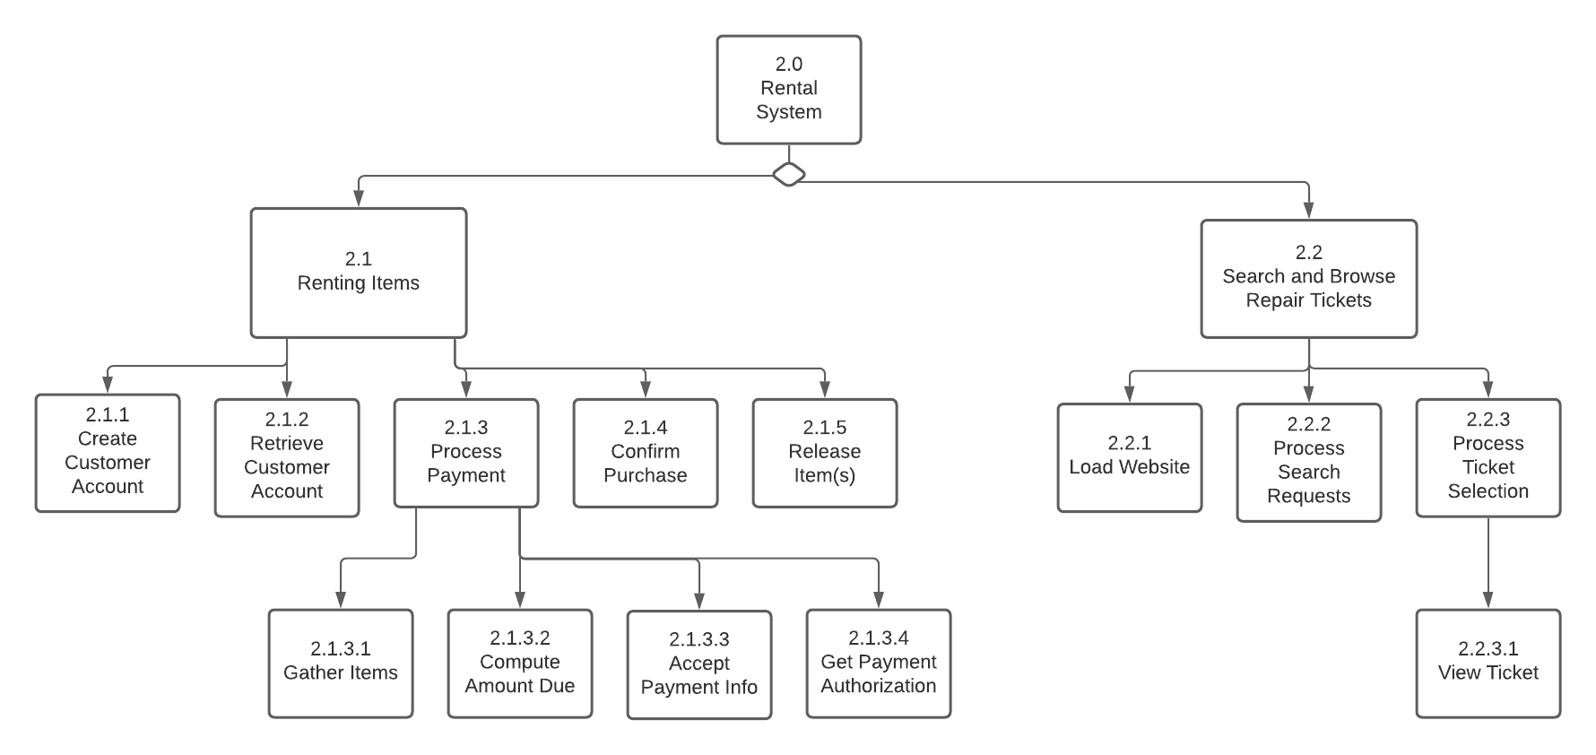

Repair System Model

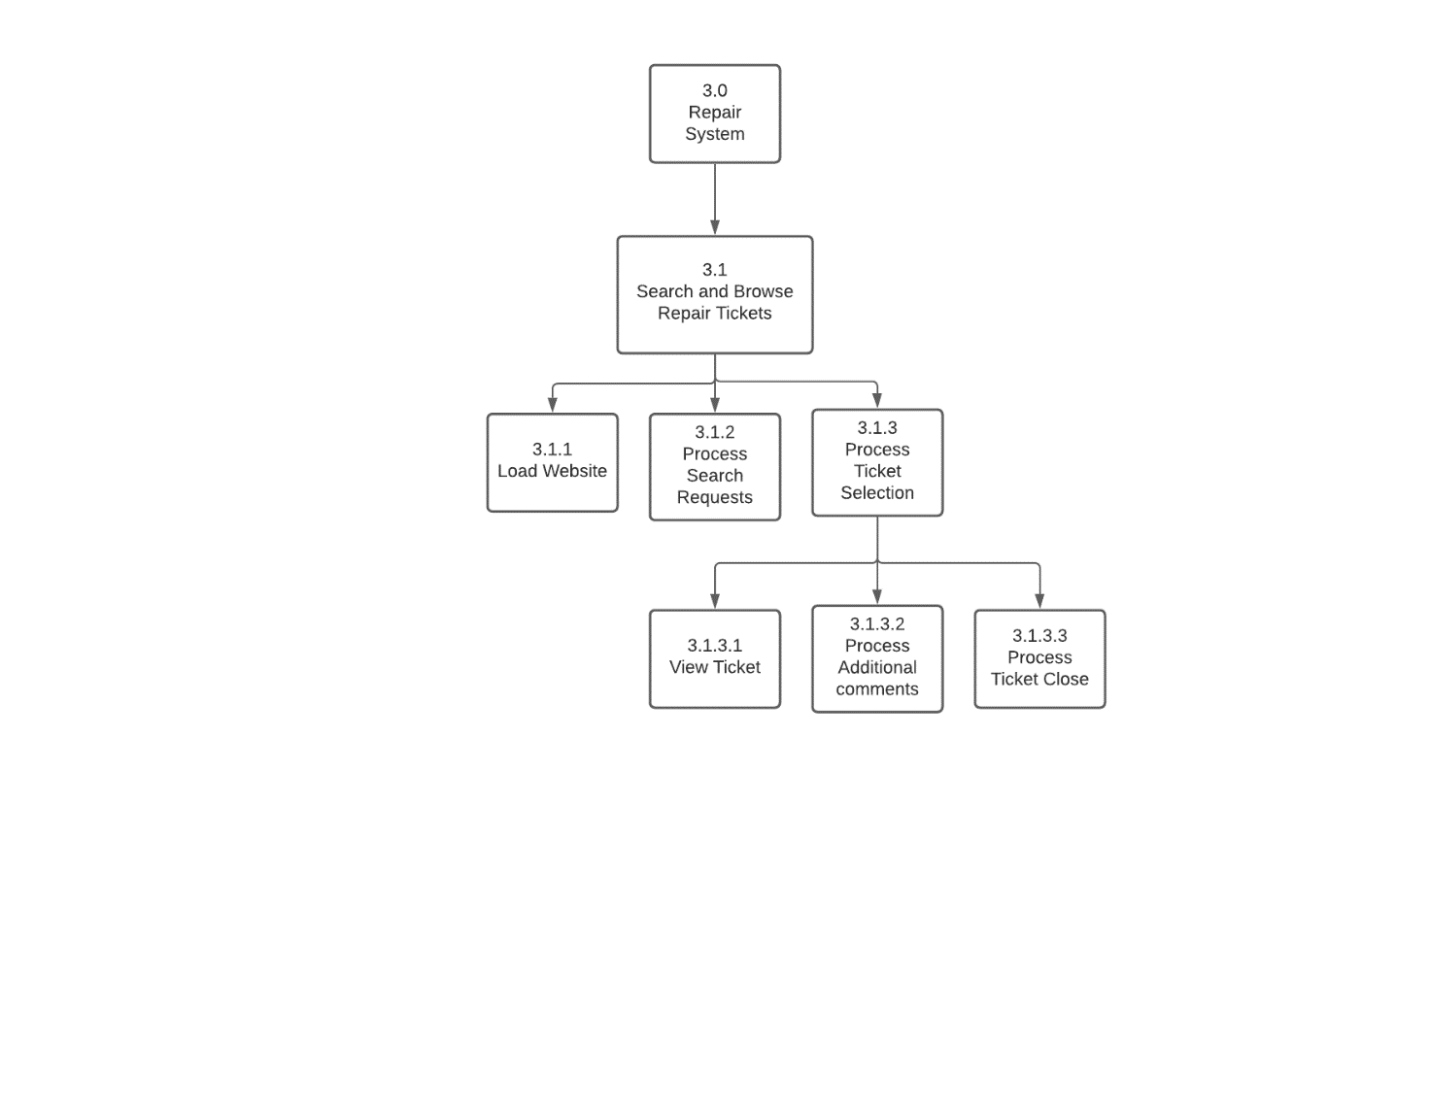

Inventory Object Diagrams

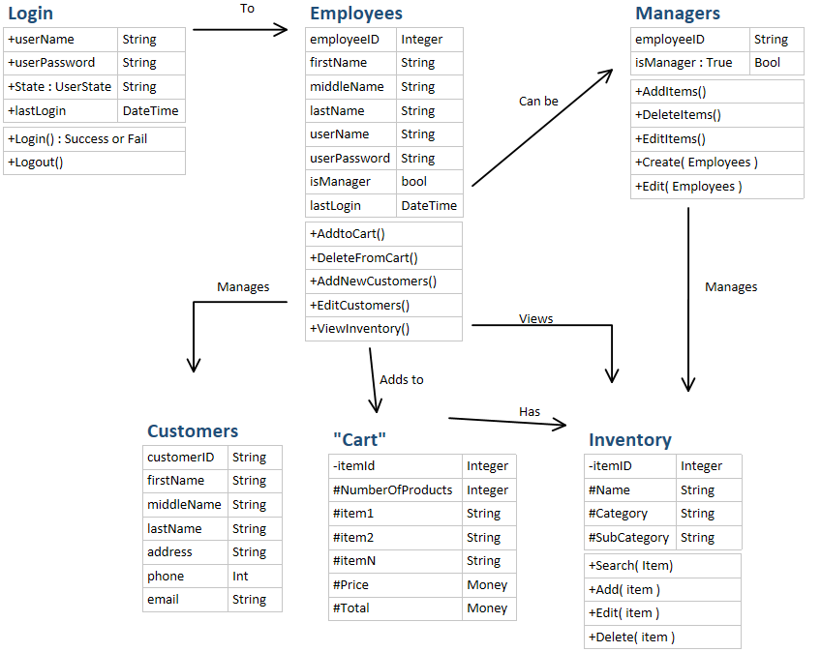

# MVC Class Diagrams



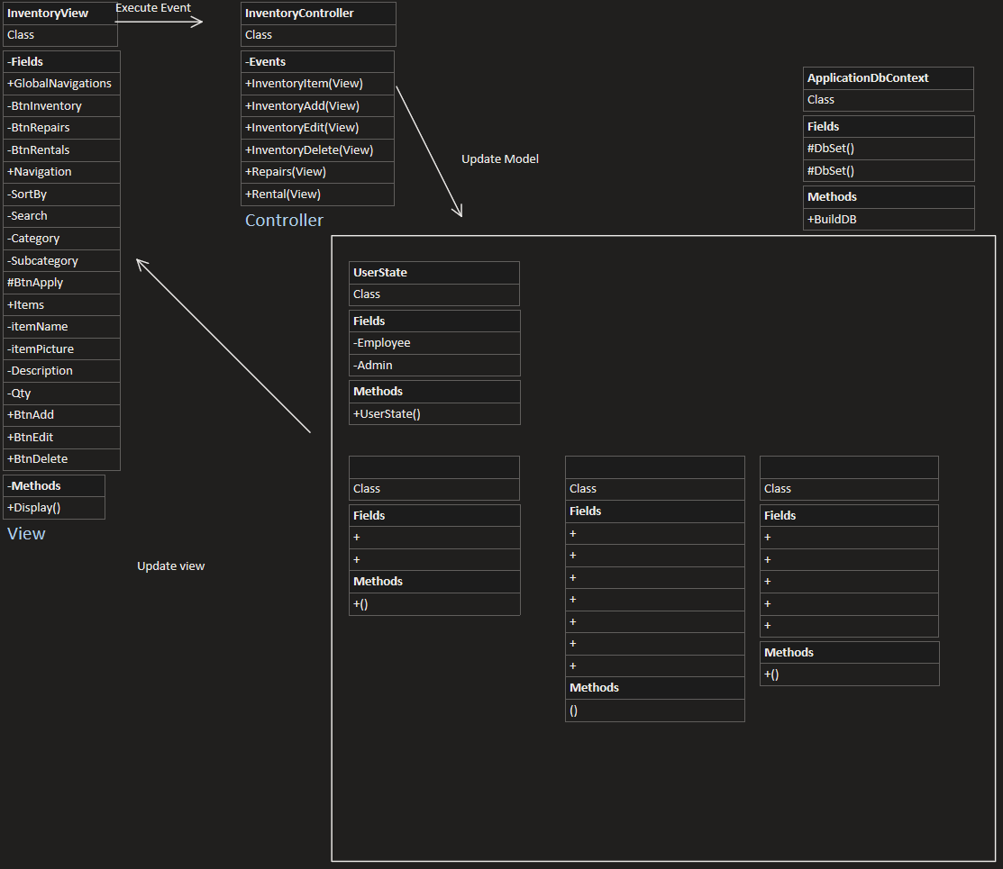

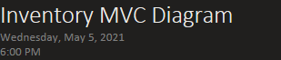

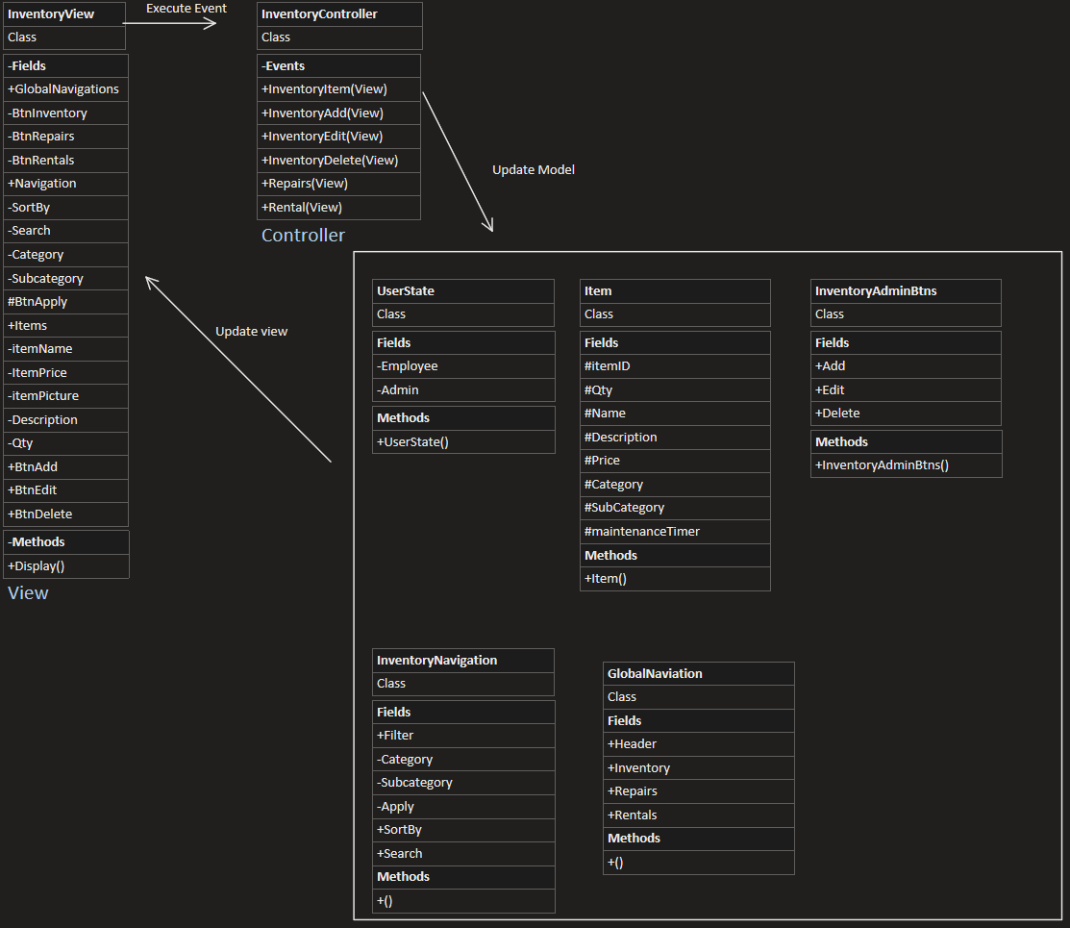

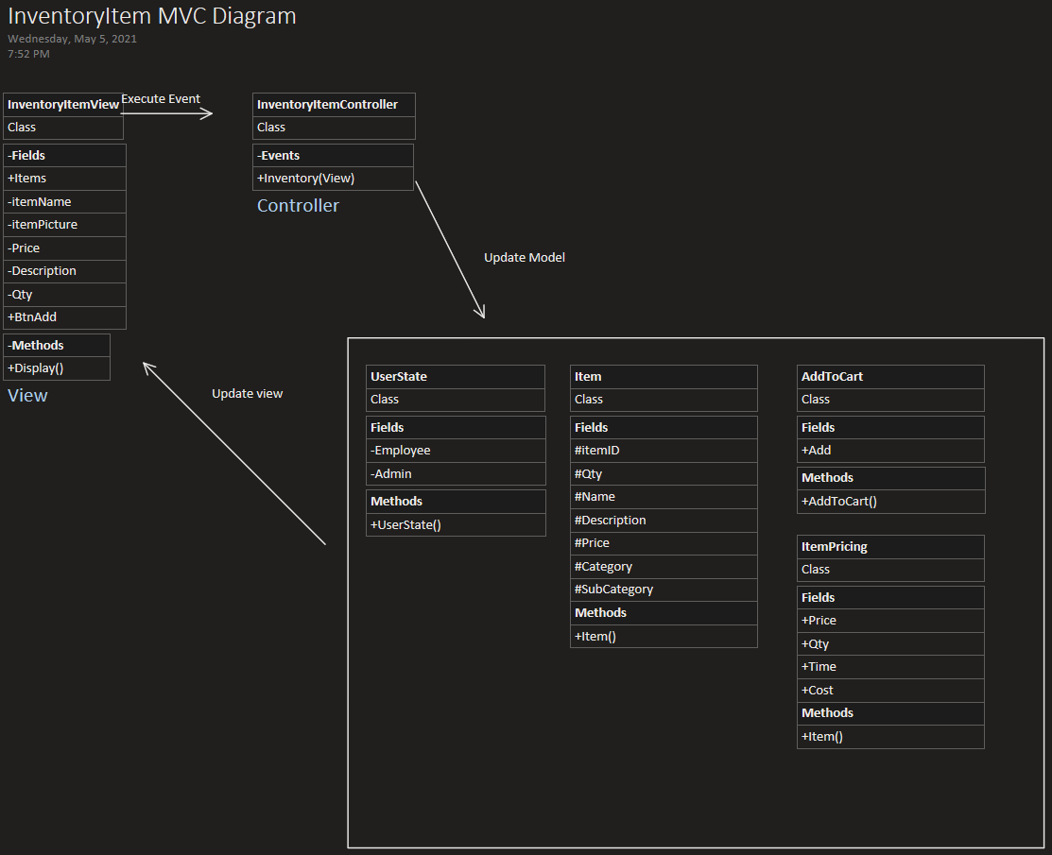

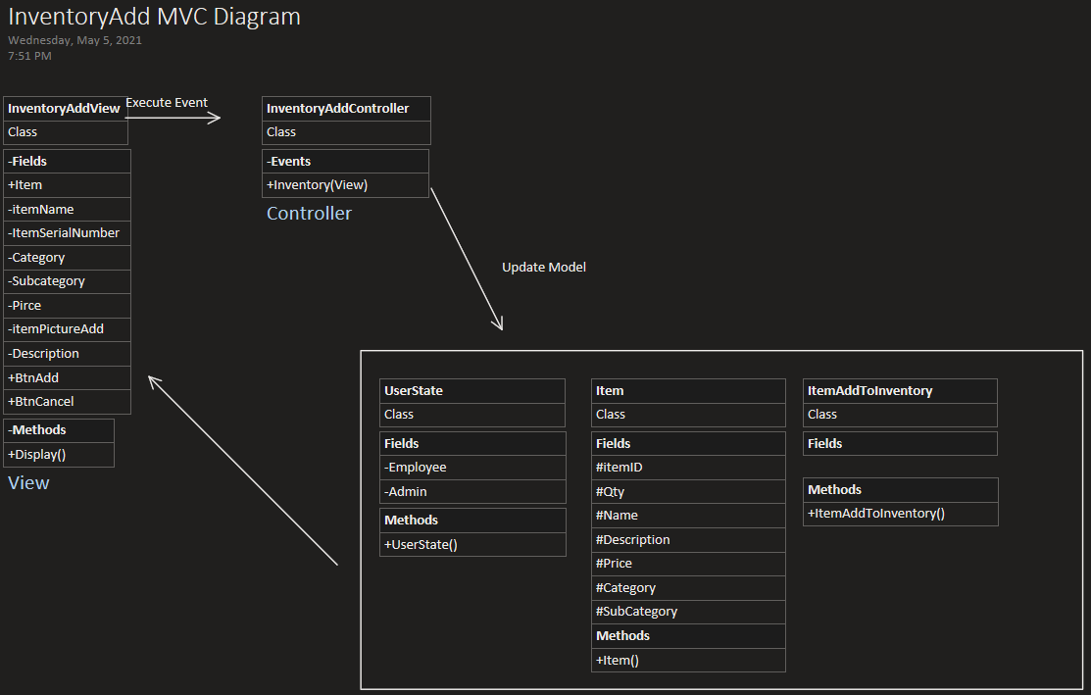

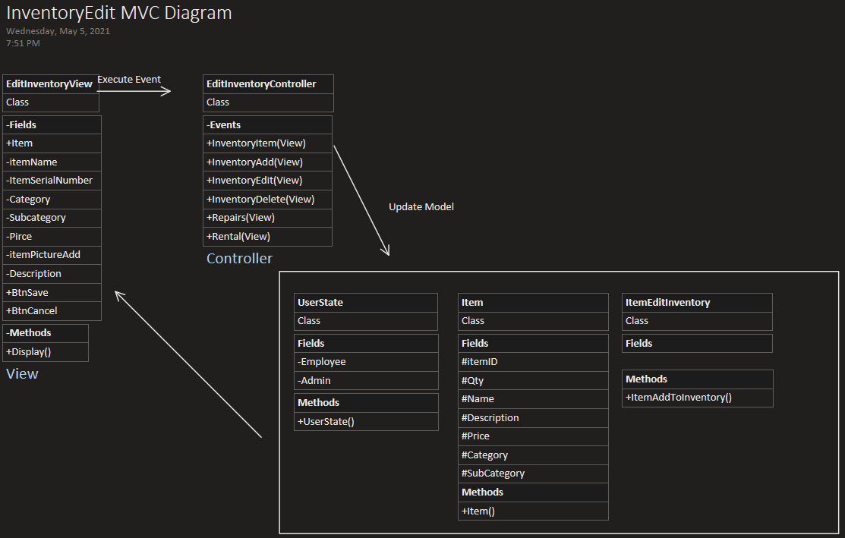

Update view



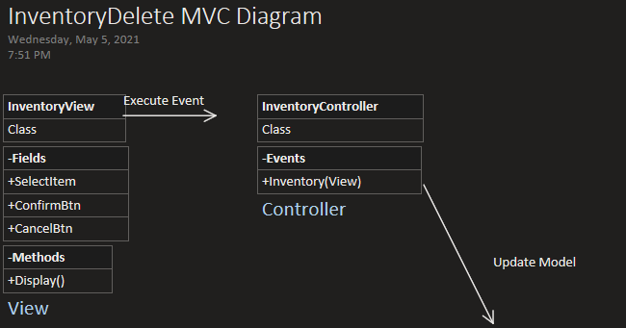

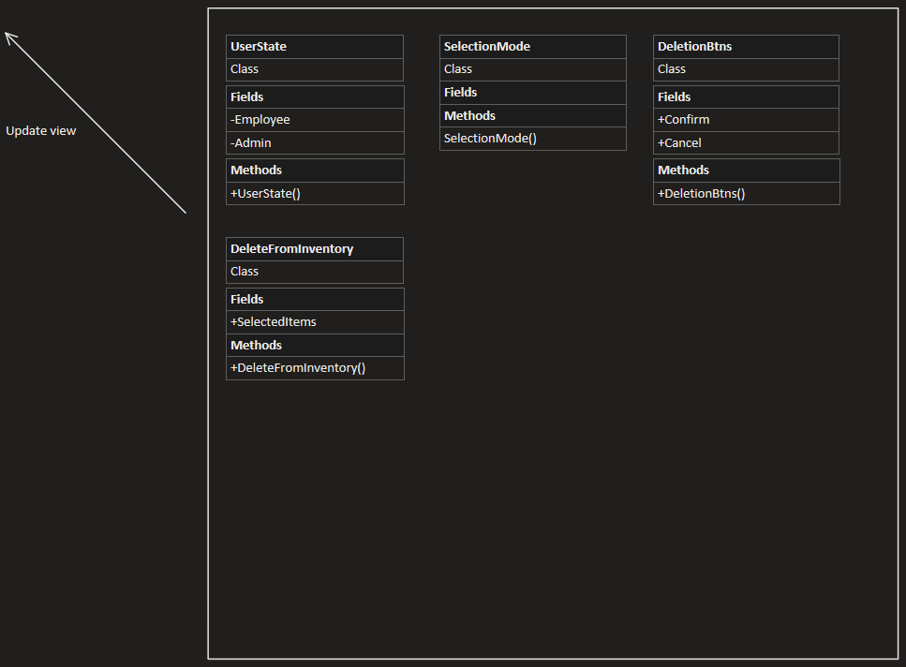

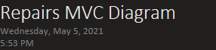

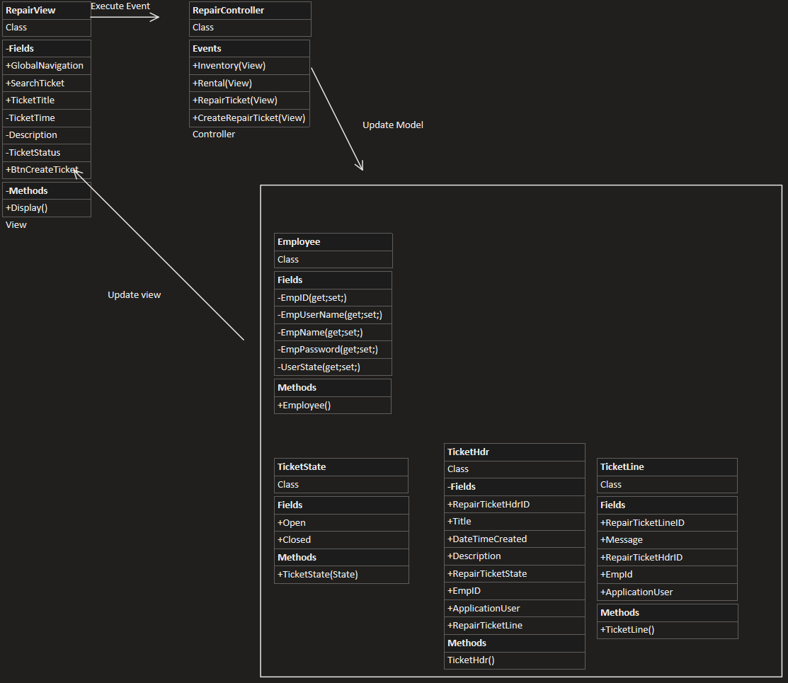

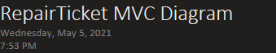

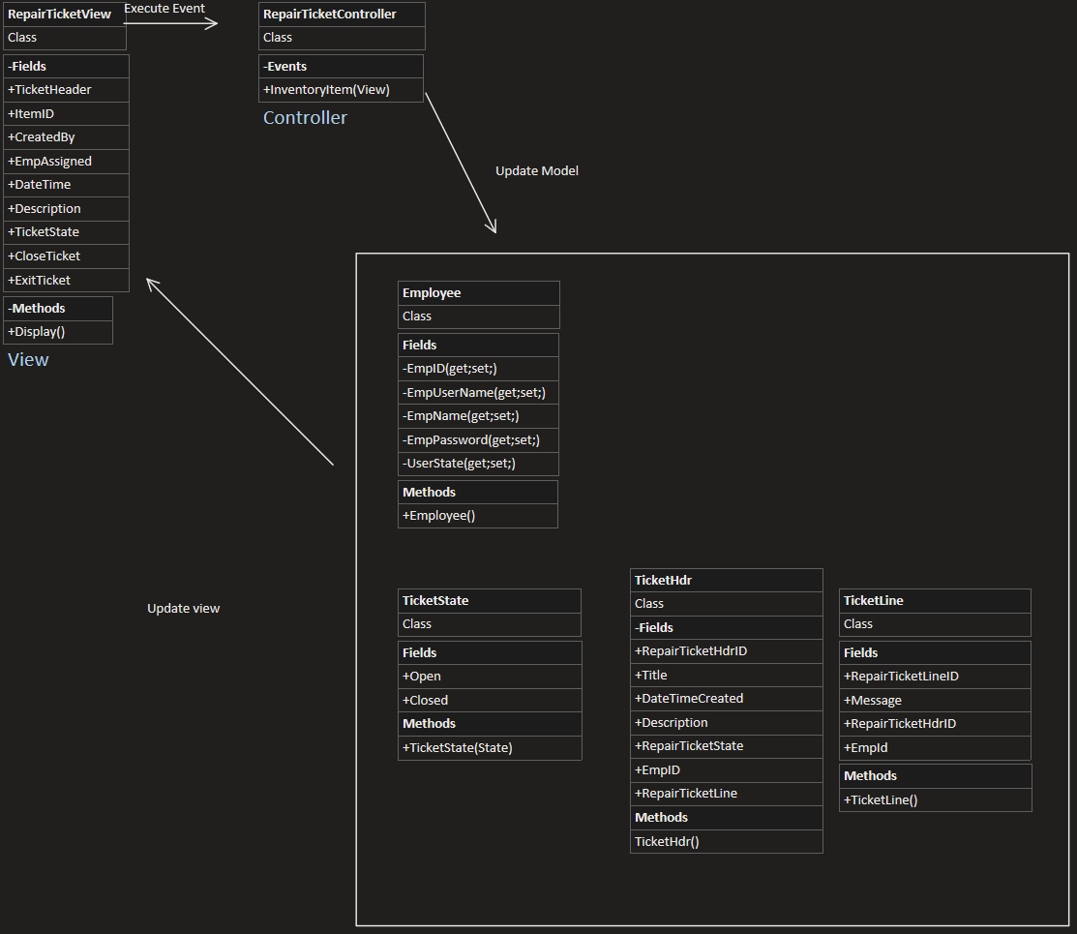

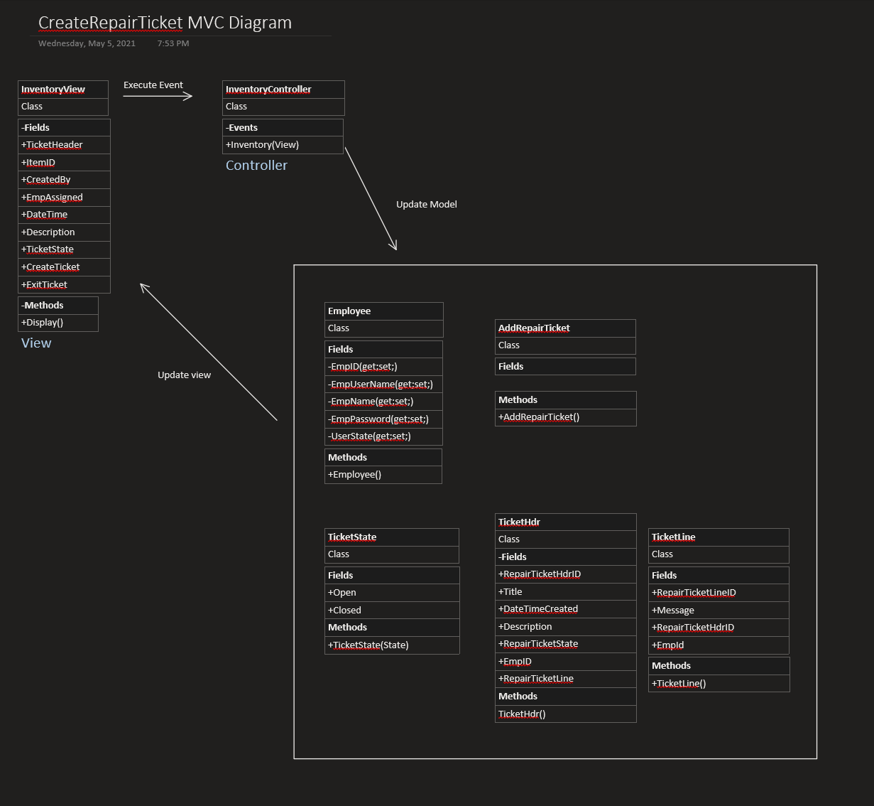

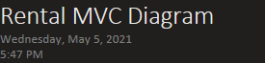

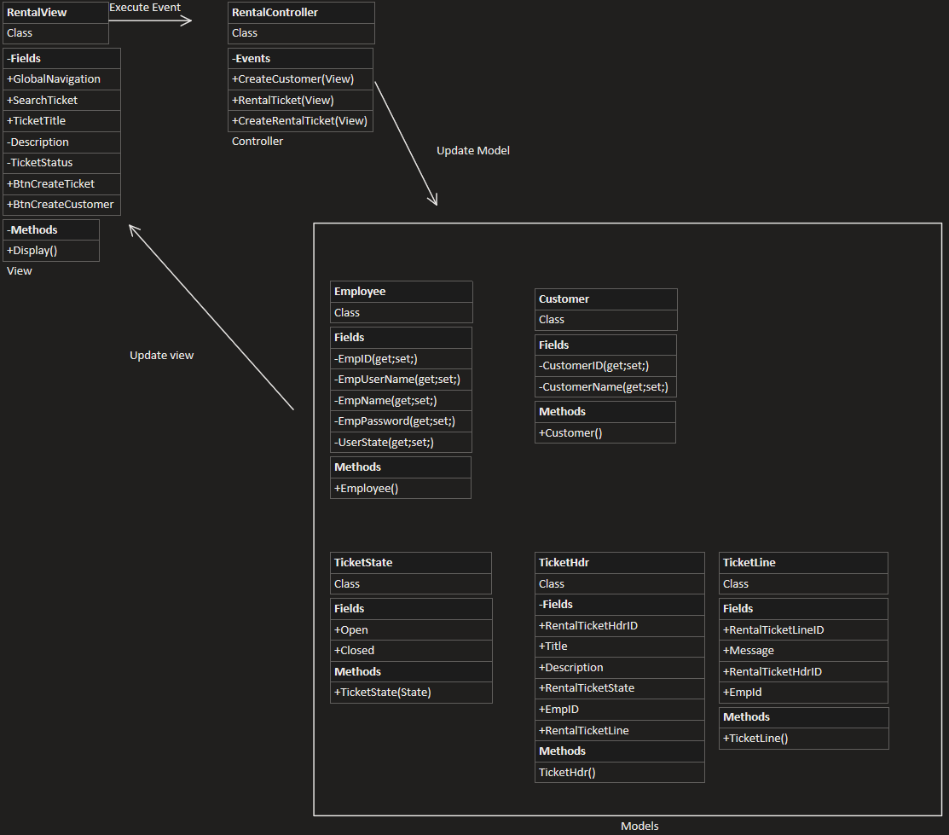

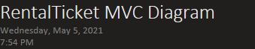

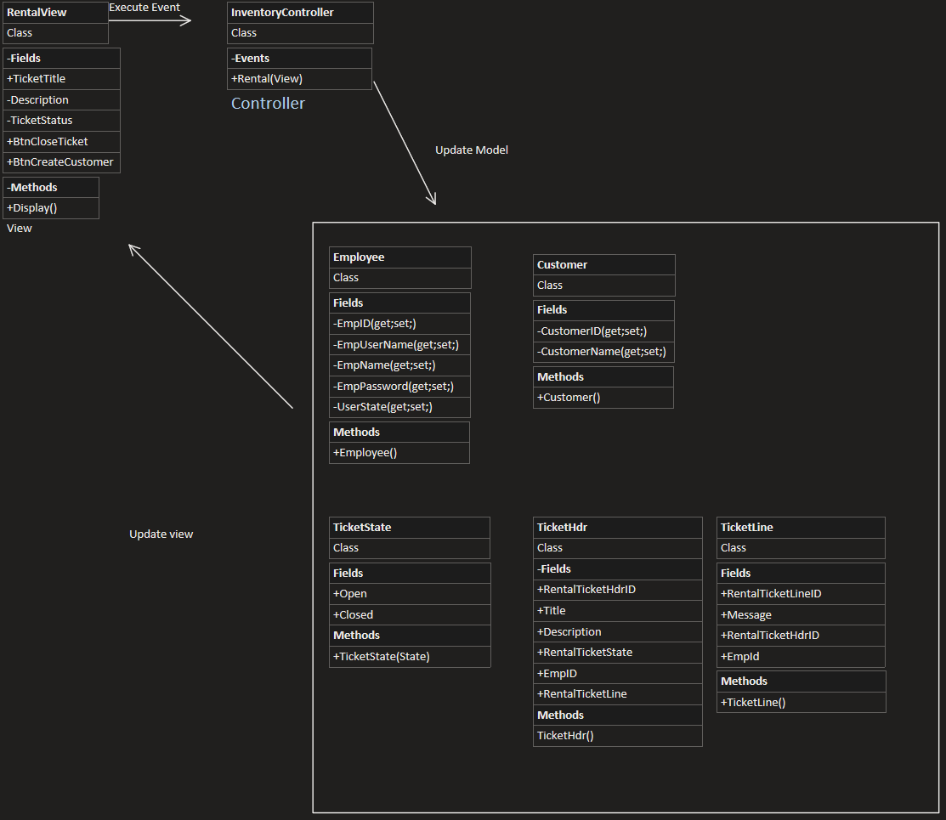

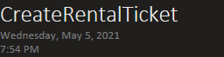

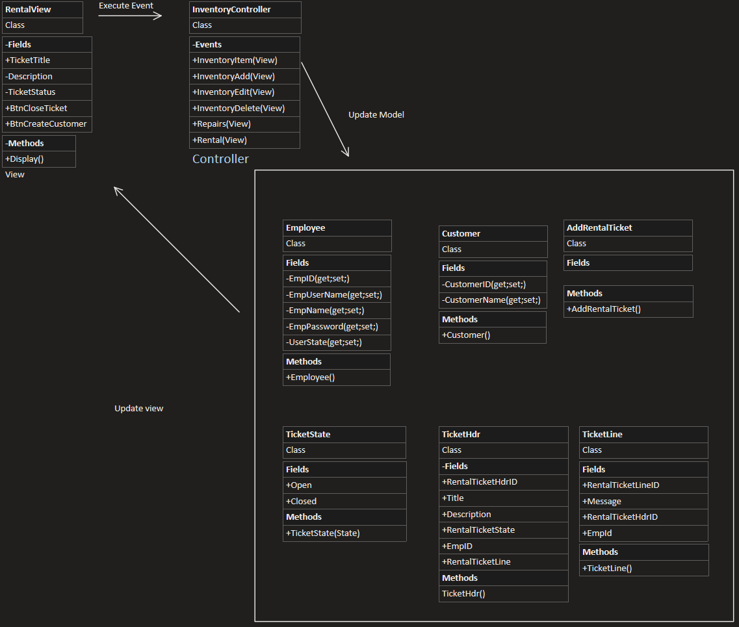

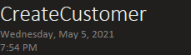

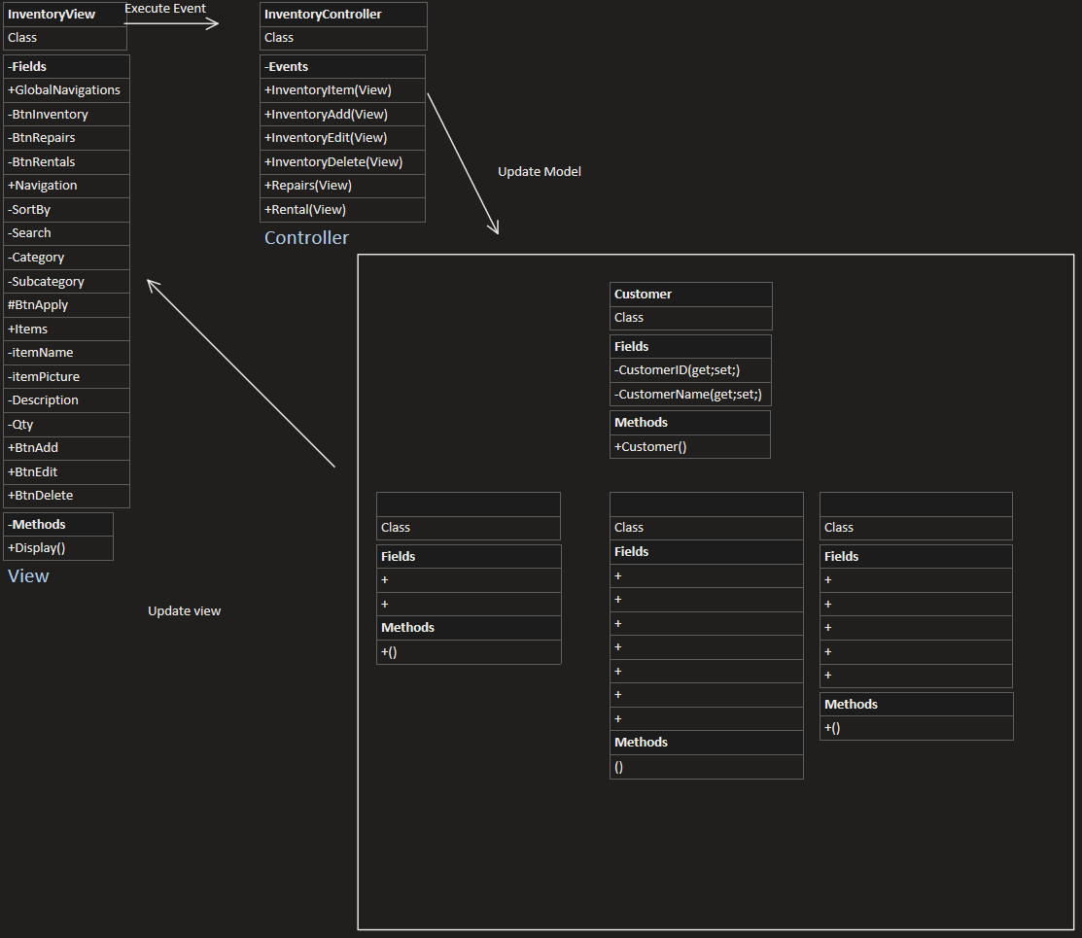

# Appendix

**Notes for Tony Cespedes Interview**

**Jovany:** What is the process of the maintenance of tools rented to other customers?

**Tony:** We run the system on the tool number selected by the customer, we ask them for their full number and select their profile. In case they don’t have a profile with Home Depot, it automatically makes one with their phone number. Then we scan their ID, which will either confirm the information in their profile, or add in the information to their profile if it's their first-time renting, then we just scan the barcode for the tool which selects the category, subcategory, and the individual tool’s ID. Then we select the time to tool is used for, like four hours or for daily, weekly use, etc. Then we just charge them the deposit and Bada Bing Bada boom they’re set to go.

**Jovany:** How does it charge the customers? Every hour, day?

**Tony:** No, it charges them for a tier of time. The shortest tier home depot has is 4 hours if the item is rented for more than 4 hours it changes the item from the 4 hours rental to a 24-hour rental, in which case they bring it back before the 24 hours the customer will be charged the 24-hour price. If it passes 24 hours, it’ll automatically change it to 48 hours (about 2 days) and so forth. It gets tricky if it passes the 1-week original return date, if the item has not been returned when it passes a week pass the original return date then the system will auto charge the customer’s card with a certain fee until it reaches the full price of the rental. And those fellas aren’t cheap they charge us two thousand dollars if you take a hammer.

**Jovany:** Two thousand dollars for a hammer?

**Tony:** Yea but those hammers are big.

**Jovany:** How do you, as an associate, fix the tools? Explain that process to me.

**Tony:** Basically, if something is damaged that needs repair or any kind of work they’re added to a separate system, not the rental system, the two systems communicate with each other but they’re separate systems. They communicate as in if a tool is down for repair therefor the repair system will remove it from the rental list, so they won’t be able to rent it out until the repair is done. Basically, it’s like a work list, it adds the tool and what wrong with it and it’ll keep track how long the tool has been under repair. Usually, they tell us that we can’t have a tool be in an initiated stage, which means the work order has been submitted, but the work order hasn’t even been looked at for more than five days. And a tool cannot be under repair for more than 12 days or it’ll go critical, it’ll basically make our numbers look bad and is something the upper management want us to avoid.

**Jovany:** So, you guys have to keep your numbers good. To make it look good on the report.

**Tony:** Basically Yea

**Jovany:** So, it’s like me working as an order fulfillment associate. “Oh, you guys took too long to bring down this one order.”

**Tony:** It basically is that, whenever they tell us to like, “Oh you gotta concentrate on this”. They give us the example of pullers trying to pull tools and merchandise.

**Jovany:** They use us as an example?

**Tony:** Yea, basically we need a system similar to that of the rental system. To keep track of days for how long a tool has been down for, what it should do is add it, like keep a schedule of how long a specific tool has been out. Like basically let a number tracker for each individual tool to let us know when it’s reached a certain amount of time that the manufacturer recommended maintenance be done on it. That would basically help us out with trivial matters wrong with the tool that could’ve been prevented with maintenance. Basically, what I said that we need is like something similar to that rental one. And instead of keeping track of days for would that a tool had been down, what it should do is add, and keep a schedule of how long specific tools have been out. Like basically let a number tracker for each individual tool to let us know when it's been, you know, went through each day, certain amount of time that the manufacturer recommended maintenance be done on it. That would basically help us out with, uh, with the call and making sure the tools don't, you know, go under repair for basic that could've been prevented.

**Jovany:** I think I was the one that suggested a checklist as well for this.

**Tony:** Yeah. You suggested that. And like I said, it, yeah, that basically is what go down to their maintenance, boom, his tool has reached 12 hours of work., it needs maintenance or else it could be damaged. Here is a checklist of what needs to be checked.

**Jovany:** What if you need like a new part or something?

**Tony:** if you need a new part, then that stops being maintenance. And that's a repair work order. Remember there's a difference between repair or maintenance, if something is broken or needs to be replaced, that's that repair maintenance parts.

**Jovany:** Yeah, that makes sense. What do you do every day though, exactly?

**Tony:** Uh, basically repairs. I do repairs every day. But yeah, I, I say that I would need that we would, not need, but we could definitely use something to help to keep track of when maintenance needs to be done. Because so many of these repair orders are a result of some machine, not having seen enough maintenance.

**Jovany:** Oh, so, there literally isn’t anything in place to help you keep track (of maintenance)?

**Tony:** Nope. All we have is the rental itself, and when it’s down for repairs.

**Jovany:** Well, I mean, (maintenance) is pretty important though.

**Tony:** Yeah! Sure is!